0000.doc

MATHEMATICS SPECIALIST 3C/3D
MARKING KEY
MATHEMATICS: SPECIALIST
3CMAS/3DMAS
RESOURCE-FREE

Question 1 [4 marks]
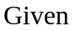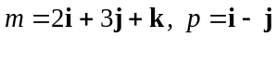 and 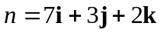:
(a) Find 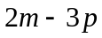

2 marks | Description
1  1 | 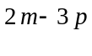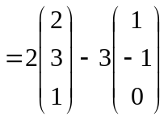  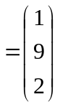

(b) Find 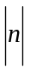.

2 marks | Description
1 + 1 | 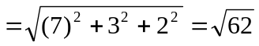

Question 2 [6 marks]

(a) 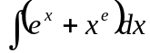

3 marks | Description
( 1 + 1 + 1) | 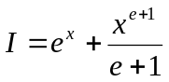+ c
(b) Show that 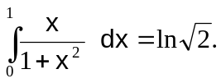
3 marks | Description
1 + 1 | 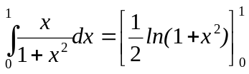
1 | 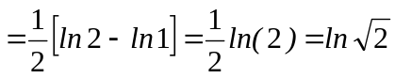

Question 3 [7 marks]
(a) Find an expression for  and hence find the equation of the tangent to the curve at the point where: 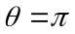

5 marks | Description
1  1 | 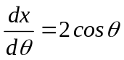  and 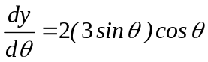
1  1 | 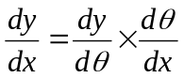  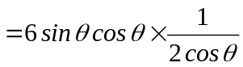  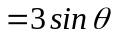
1 | At , 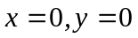 and 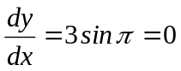.  Hence the equation of the tangent is 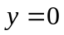

(b) Determine the Cartesian equation of the curve.

2 marks | Description
1 | From above 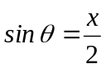 and 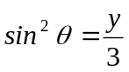 or 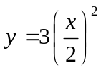
1 | So 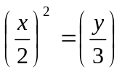 or, directly 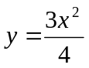

Question 4 [10 marks]
(a) Find the solution to 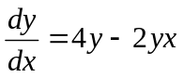 satisfying 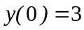.

5 marks | Description
1 | Factorising: 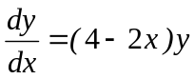
1 | separating variables: 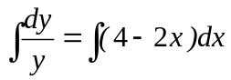
1  1 | 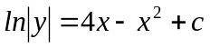  ∴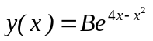
1 | From 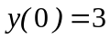 we find B=3, so that 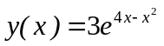

(b) Use algebra and explain your reasoning, solve exactly the inequality |sin 2x| sin x over the interval 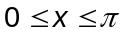.

5 marks | Description
1  1 | If  then 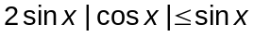  as 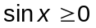 across the whole of the interval
1 | Thus need 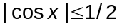 or x = 0 or x = π
2 | implying that 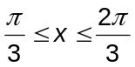 or x = 0 or x = π  (-1 for each incorrect solution or inequality written as 1.05<x<2.09).

Question 5 [6 marks]
(a) Verify that:
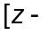cis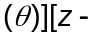cis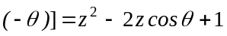.

3 marks | Description
1  1  1 | 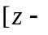cis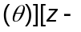cis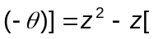cis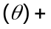cis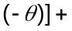cis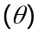cis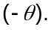 [1]  Now cis()+cis(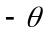) = and cis()cis()= ( [1]  so that 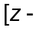ciscis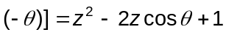 as required.

(b) Sketch the following subset of the complex plane:
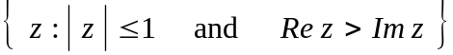

3 marks | Description
1 circle  1 shading  1 boundary | 1  i  -1  -i  Re z  Im z  origin excluded

Question 7 [7 marks]
The sum of the products of two consecutive positive integers seems to have the form,
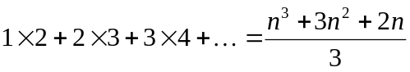
Prove that this conjecture is true for all positive integers, n.

7 marks | Description
1 | Firstly, show that the conjecture is true for n = 1  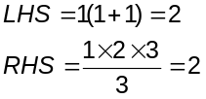  - as required  Now, assume the conjecture is true for n terms, and consider the expression for n+1 terms | Firstly, show that the conjecture is true for n = 1  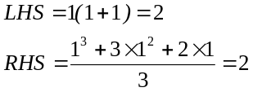  - as required  Now, assume the conjecture is true for n terms, and consider the expression for n+1 terms
1  1  1  1  1 | 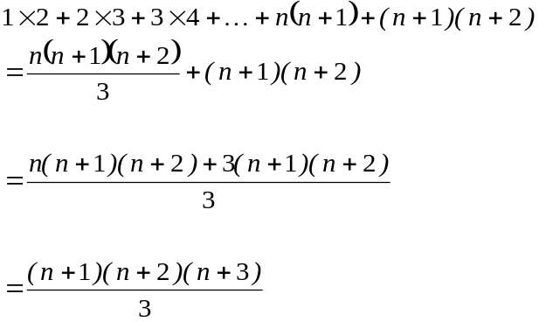  which has the same form as for the n^{th} term and so the statement is true for all n. | 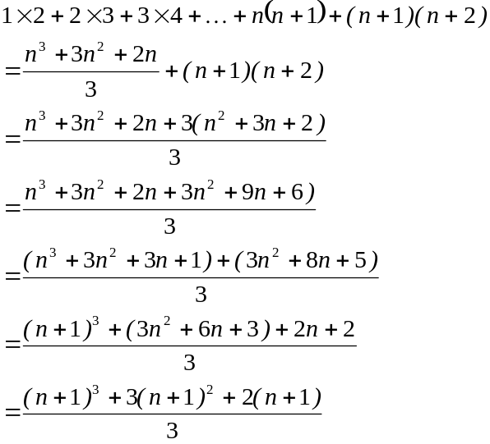  which has the same form as for the n^{th} term and so the statement is true for all n.

MATHEMATICS: SPECIALIST
3CMAS/3DMAS
RESOURCE-RICH

Question 1 [5 marks]
If 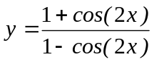, show that 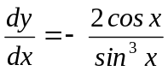.

5 marks | Description
1  1 | 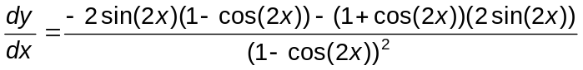
1  1 | = 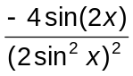
1 | = 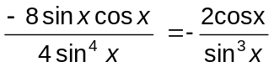

Question 2 [6 marks]
Given the following expression 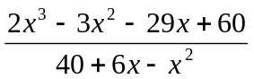

- Simplify the expression.

2 marks | Description
1  1 | factorise as 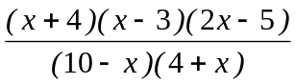 or use CAS to give  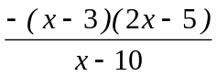 or equivalent

- For which value(s) of x, if any, is the original expression not defined.

2 marks | Description
1 | 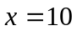
1 | 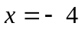

- Compare the original expression and its simplified version. Are there any values of x, where these two expressions are unequal? Explain your answer.

2 marks | Description
1 | yes
1 | the simplified expression has a value at , whereas the original expression is undefined at that value

Question 3 [5 marks]
The diagram below shows the polar graphs of r = k and r = nθ (n an integer).
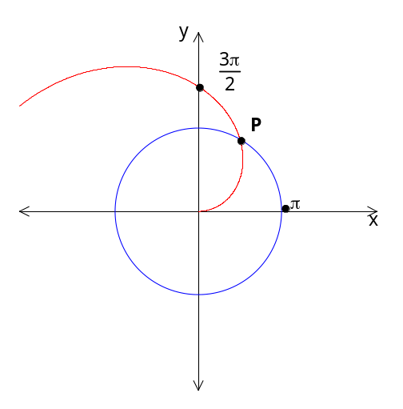Also, the point of intersection of these two graphs is point P.

(a) Write down the values of k and n.

2 marks | Description
1 | k = π
1 | and since 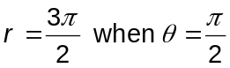 , n =3

(b) Determine, EXACTLY, the Cartesian coordinates of point P.

3 marks | Description
1 | i.e. 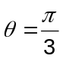 so P(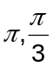 ).
1  1 | Now convert to Cartesian –  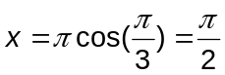 and 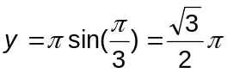   P(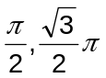).

Question 4 [8 marks]
(a) By comparing:
- the areas of sector OPQ and triangle OPB
and
- the lengths of PB and arc AB,

or otherwise, establish the inequalities 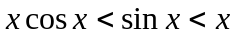.

4 marks | Description
1 | 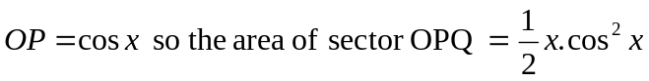
1 | 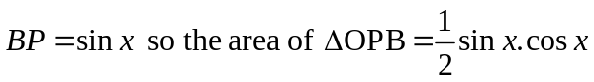
1 | 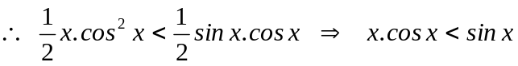
1 | 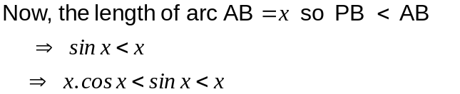

(b) Explain why the above result shows that 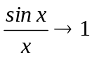 as  and hence,
determine: 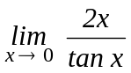.

4 marks | Description
1 | 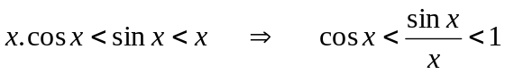
1 | 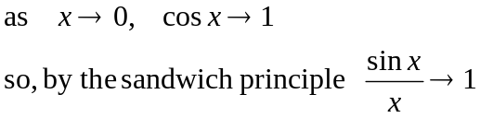
1 | 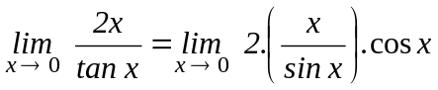
1 | 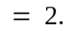

Question 5 [7 marks]
Calculate the minimum distance they are apart and the time, after the aircraft leave their initial positions, when this distance is reached after the aircraft leave their initial positions.

7 marks | Description
1  1 | The displacement between the two toys at any time t is given by:  d = (r_{A} + v_{A} t) – (r_{B} + v_{B} t)  = 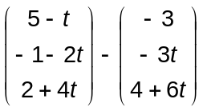  = 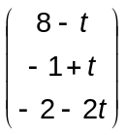 where t represents time in seconds
1 | Hence 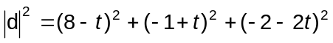  = 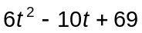
2  2 | Now by completing the square, using calculus or a graphics calculator (most likely) we find that the minimum value of 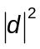 is when 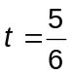 seconds at which time = 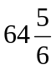.  Hence the minimum distance they are apart is 8.05 m (to 2 dec pls) and the time taken is or 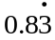 seconds.

Question 6 [9 marks]
(a) Show that 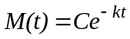 satisfies the differential equation for any constant C.

2 marks | Description
2 | If 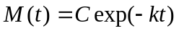  then 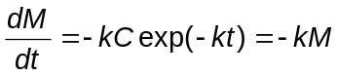and so satisfies the DE.

(b) Find k and C.

3 marks | Description
1 | If 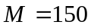 when 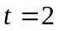 then 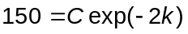and if 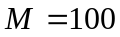 when 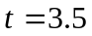 then 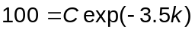or
1 | Dividing the equations gives 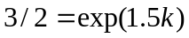 so 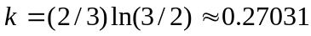.  an alternative solution method for k 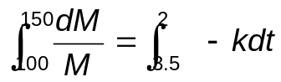  solving for k gives 0.27031
1 | 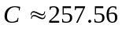.

(c) How long will it take for the mass of the substance to reduce to 40 grams?

2 marks | Description
1  1 | When 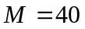 have so that 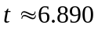.  Hence substance reduces to 40 grams after approximately 6.89 years.

(d) Find the radioactive half-life of the substance.

2 marks | Description
1 | Initial mass of substance is C; half-life is defined to be time taken for mass to drop to 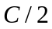.
1 | years.

Question 7 [7 marks]
Consider the curve 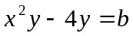 where b is a real value.

- Determine the equation of the tangent line to this curve at the point (x₁, y₁).

4 marks | Description
1  1  1 | Differentiating implicitly and re-arranging to find the derivative  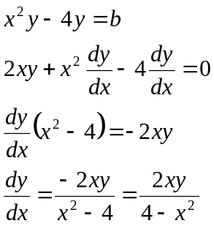
OR  1  1  1  1 | OR rearranging first :  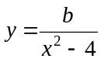  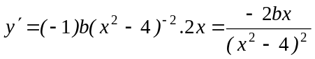  thus, at (x₁,y₁), gradient is 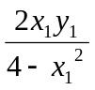  then the equation of the tangent to the curve at (x₁,y₁) is  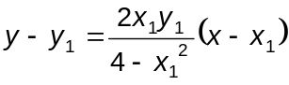

- What is the restriction on b so that the curve has a vertical tangent line at the point (x₁,y₁)?

3 marks | Description
1  2 | 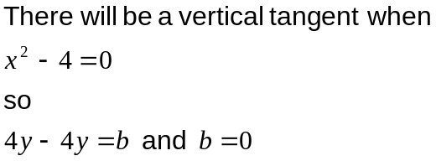

Question 8
Solve the inequality 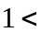 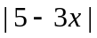 < 9 algebraically.

Solving 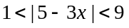
5 Marks | Description
1  1  1  1 | If 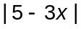 <9 then:  (i) either 5-3x > 0, x < 5/3 and 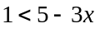 and 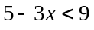  ∴ 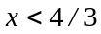 and 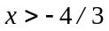  the intersection is 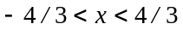  or 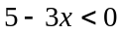, x> 5/3 and 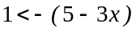 and 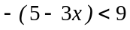  ∴ 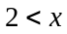 and 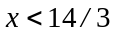  the intersection is 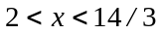
or
1 set up  1 for the modulus graph  1 for lines  1 | If answer is based on a graphical solution, such as the one shown below:  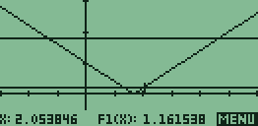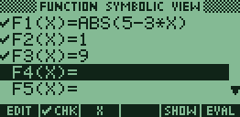  so or 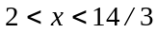
1 | Correct intervals 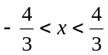 or 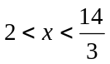, stated exactly.

Question 9 [6 marks]
Use a vector method to prove that the mid-points of the sides of a quadrilateral form a parallelogram.

6 marks | Description  G  A  B  C  D  H  F  E
1 | Appropriate diagram
1 | (symbolic set-up) 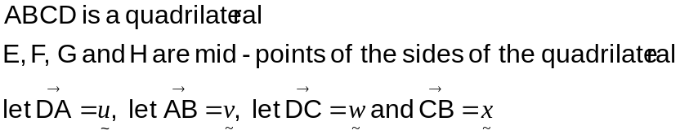.
4 | (clear, logical proof)  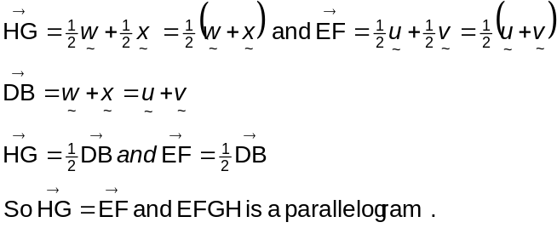

Question 10 [12 marks]
(a) Suppose that z is a complex number with modulus r and argument .
Express in terms of r and the modulus and argument of each of the complex numbers 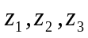 and 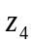, where:
(i) 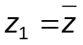

2 marks | Description
1  1 | 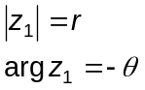

(ii) 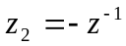

3 marks | Description
1  1+1 | 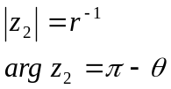

(iii) 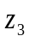 and are the square roots of z.

3 marks | Description
1  1  1 | 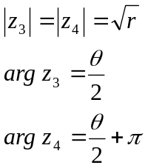

(b) Indicate as precisely as you can on the diagram above the locations of the complex numbers 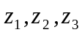 and, as defined in part (a).

5 marks | Description
(1 mark - for each point correctly located and labelled)  4 | 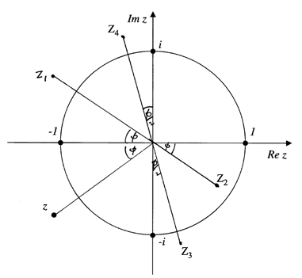

Question 11 [10 marks]
(a) If initially there are 150 kids, 200 yearlings, 200 adults and 80 old goats what is the distribution after 20 years?

3 marks | Description
1 for 20th power  1 layout + multiply  1 interpret solution | 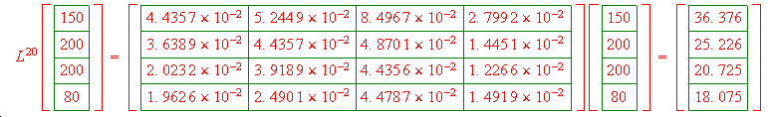  2 for knowing what to do, 1 for the result which can be done by calculator

(b) Determine the net reproduction rate of the population of female goats.

3 marks | Description
1  1  1 | 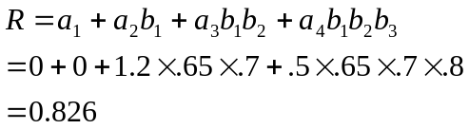

(c) Assuming there are enough male goats to fulfil their part, will the population of female goats become stable over time (that is, survive in the long run)?

4 marks | Description
1  1  1  1 | using previous result in (a),  and finding a higher power of L in the recursive relationship, indicates that this population appears to be increasing without limit, which is an unrealistic expectation.  However, based on the assumption of ample food and no external threats, this population would survive in the ‘long term’.

